An Analysis fo the Effect of Adult Spawning Density
In Producing Steelhead from Resident Parent Rainbow Trout

Conor Curran

FISH 450 Fall 2017

Abstract:
Migration is a hallmark aspect of salmonid life histories, and one which is shared, to some degree, among all species. When involving movement from fresh to salt water it is known as anadromy. This particular type of migration is characterized by movement from fresh water to salt water and then a return to fresh water. In anadromous fishes the offspring enter the salt where they remain until reaching maturity, at which point the fish return upstream to spawn. For many species and populations, the entire population either migrates or remains in their freshwater environment. One species which is a clear exception to this rule is Oncorhynchus mykiss. This species has the distinct quality of hosting populations which may simultaneously produce both resident individuals, rainbow trout, and anadromous individuals, steelhead. The purpose of this experiment is to determine factors which might influence the production of anadromous offspring from two non-anadromous parents. The experiment revolves around creating variable spawning conditions among distinct groups of adult fish and determining the percent of anadromous offspring produced, through sampling and DNA reference to parent groups. In doing so, the study will be testing the hypothesis that higher density of adult O. mykiss during the spawning season will result in a greater percentage of offspring maturing to anadromous type steelhead. It is still unclear how or why exactly this species exhibits this particular quality and the results of this study will aid in developing a greater understanding of O. mykiss life history.

Introduction:
In the study of Salmonid life histories, the complex series of morphological and behavioral changes relating to fish migration are under constant study. A facet which makes the study of salmonid life histories intriguing is the observation of partial migratory behavior in populations. Partial migration or in this case partial anadromy refers to the presence of individuals within the same population which participate in anadromy and maturation in salt water while others of the same population reside in freshwater throughout maturation (Jonsson and Jonsson, 1993).
Partial migration is frequently observed in Oncorhynchus mykiss, referred to as rainbow trout when resident and steelhead when anadromous. O. mykiss not only host both anadromous and resident individuals simultaneously, but are capable of producing anadromous individuals from two non-anadromous parents and vice versa (Christie et al. 2011). The life history of O. Mykiss is made even more interesting by the finding that even when populations have access to a body of salt water, there are individuals which do not produce any anadromous offspring (Courter et al. 2012).
Due to its particular life history, and the ability to have migratory variation within populations, O. Mykiss draws interest from a variety of scientific fields. Many theories have been hypothesized to accurately describe what it is about the life history of O. Mykiss that leads to this variability, including the potential impact of migration distance among isolated populations (Ohms et al. 2013) and the influence of physical water conditions such as temperature on the rate of anadromous offspring being produced (McMillan et al. 2011).
The idea of density dependent migrations is one which has been explored in species outside of the fisheries realm. Density dependent migration refers migration undergone as a response to population conditions. It is most apparent in one of two situations; when the population density is so low that the individuals within experience diminished mate choice and collective defense, or conversely when density is so great that competition exceeds the resources of the environment in terms of feeding and reproduction (Ruxton. 1996). As a mechanism which has been observed in multiple species, it seems feasible that O. mykiss might have a similar mechanism in response to population density.
Objectives:
The purpose of this project is to understand how the spawning conditions of O. Mykiss might affect the percentage of offspring, produced by two non-anadromous parents, which go on to exhibit anadromy later in life, and mature in salt water as steelhead. As it is still not entirely understood what conditions contribute directly to the production of anadromous offspring from resident parents, the goal of this experiment is to determine the effect of population density at the time of spawning for resident rainbow trout on the percentage of offspring which will participate in anadromy. The null hypothesis is that population density at the time of spawning will have no impact on determining the percentage of anadromous offspring. The alternative to this hypothesis is that higher population densities of resident rainbow trout during spawning events will result in the production of offspring which will in turn exhibit higher percentages of individuals maturing as anadromous rainbow trout.

Methods:
To test the hypothesis, it will be necessary to procure a sample of non-anadromous rainbow trout to serve as the parental group. It is paramount to select a parental group from a system which contains both resident rainbow trout and anadromous steelhead, necessitating a freshwater system which flows into saltwater. It will be necessary to collect enough mature adults to create three healthy groups of individuals, one to act as a control group, one to be exposed to lower population density, and one to be treated to higher population density at the time of spawning. As such, a hatchery present on such a river will provide the established brood stock and facilities necessary to conduct the experiment. These treatments will then be produced within the hatchery, with all three groups separated into contained environments or enclosures, to ensure there is no mixing of the groups and to allow for easier observation.
Establishing three separate enclosures within a pre-established hatchery for the three parent groups, the environment within each enclosure will be controlled for to eliminate any other variables which could potentially bias the experiment. This will mean creating the exact same water conditions, temp, dissolved O₂ levels, etc., ensuring that each enclosure is the same size, as well as providing food equivalent to the density of fish in each tank. By controlling for these factors, the goal is to isolate the groups response to only one variable, the density of individuals within the enclosure.
Group 1 will be the control group, it will be set to emulate natural, on average, densities of resident rainbows found in the hatchery’s river system. Group 2 is the group being exposed to lower than average counts. Finally group 3 will be our high-density group, with a greater number of mature individuals present in the enclosure. Group 2 will be set to contain 75% of the average density of individuals, while group 3 will contain 125% of the normal average. Each group will be genetically analyzed and cataloged for reference later. During the fish’s spawning season, the eggs will be collected and fertilized and then allowed to incubate and hatch. The offspring will then be held, still as isolated groups, until they enter the fry stage of life, and then will be released back into the hatchery river system. From this point, we must account for the fact that steelhead juveniles may spend anywhere from one to three years in the freshwater system before migrating to the ocean, and that two years is the most common smolt age. However, it has also been shown that hatchery conditions produce smolts as young as one year (Busby et al., 1996). To address this issue, we will delay attempts to recapture the juveniles one year after release date, as the experimental conditions are most comparable to hatchery rearing. For recapture we will utilize screw traps at the terminus of the river system, just before the estuary, in an effort to catch outgoing smolt. A number of these traps will be installed to maximize the sample produced. By placing these traps as far downstream as possible, we can be more certain that individuals captured so close to the estuary are in the process of migrating from fresh to salt water. It will then be possible to determine from which parental group they were produced, by using DNA markers, referenced to the catalog taken of each parental brood. The genetic referencing will be performed by University of Washington undergraduate students, who will analyze the data as provided by the hatchery. A graduate student will assist in both the operation within the hatchery, as well as with the undergrad identification work.

Timeline:
Task | Duration | Time of Year | Year
Collection of Brood | 3 months | Spring | 2018
Egg incubation | 1 month | Summer | 2018
Juvenile rearing | 1 year | summer | 2019
Juvenile collection | 3 months | Summer | 2019
Data analysis/ Interpretation | 3 months | Fall | 2019
Reporting | 3 months | Winter | 2019

Expected Results:
If the alternative hypothesis is supported, we can expect to observe a higher percentage of steelhead in subsequent years produced from the parent group which was subject to higher fish densities at the time of spawning. The reasoning being, that in a controlled environment, perhaps the higher than normal density of individuals might trigger the production of more offspring choosing anadromy, as a natural mechanism to control the sustainable density of the group’s environment. In layman’s terms, if there are too many fish in the environment, perhaps a natural mechanism is triggered which encourages a greater number of offspring to participate in salt water migration, as a means of lowering the number of individuals present in a given location. If this holds true, we should also see a relation of fewer returning anadromous adults produced from the low density group, than from both the high and control density groups.

Potential Difficulties:
One of the obstacles in completing this experiment will be the extended frame of time necessary to analyze the effectiveness of the procedure. As migrating steelhead juveniles are not as ritualistic in their migration timing as other salmonids, the timing of screw trap installation will have to be in a manner aimed at highest capture rates. It would not be feasible to operate the traps for the entirety of the period which steelhead can potentially migrate, a matter of multiple years. In addition, the influence of unaccounted for factors is possible, but it is for this reason that the hatchery setting, with controlled conditions across all three groups seems the most conducive to achieving the desired results. It is also possible that the parent groups produce no anadromous offspring, however the selection of a river system containing both steelhead and rainbow trout, as well as selecting an established hatchery which produces both to conduct the experiment, should diminish the possibility of this occurring. Finally, it is possible that there is no correlation between spawning density and percent of anadromous offspring, in which case the experiment will not yield the expected results.

Budget Justification:
This experiment will require the oversight of one full time faculty member from the University of Washington School of Aquatic and Fishery Sciences. They will receive a payment of $8,000.00 dollars for their work in assisting and guiding data review as well as experimental design. The experiment will also require the assistance of SAFS staff member, who will help in data analysis and reporting, as well as oversight at the hatchery location. A grad student will be leading work on the experiment, producing the final experimental report as well as doing a large majority of analysis on the experiment. The grad student will be working directly with involved undergraduate students, for whom a total of 300 working hours have been allocated, to be split among a number of students, dependent upon involvement from current SAFS undergrads. Although the experiment will be ongoing for approximately 20 months, a large majority of that time will be the delay between the release of fry and the installation of screw traps one calendar year later. This study will require the use of vehicles, which can be obtained through the University of Washington’s fleet services UCar rentals, and a budget of $300.00 or roughly 10 travel days has been allocated. The large expense items for this experiment will be the salmon screw traps, necessary in the recapture of smolt, for which a budget of $10,000.00 has been determined. The study also requires designated holding tanks for the parent groups, we are asking for $5,000.00 to be spent only if the hatchery does not possess adequate tanks to be rented for the experiment. We have also included a fee of $8,000.00 allocated to the payment of hourly rental for hatchery facility space. The study will also be offering a tuition stipend to involved undergrads, equaling one year, or four quarter’s worth, of tuition at the University of Washington.
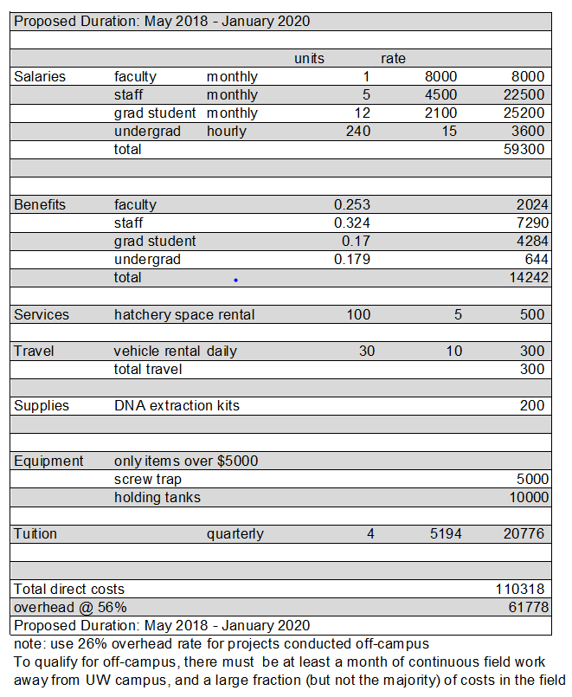
Budget:

References Cited
Busby, P.J., T.C. Wainwright, G.J. Bryant, L.J. Lierheimer, R.S. Waples, F.W. Waknitz, and I.V. Lagomarsino. 1996. Status review of west cost steelhead from Washington, Idaho, Oregon, and California. National Marine Fisheries Service Technical Memorandum. NMFS-NWFSC-27. 15-55.
Christie, M. R., M. L. Marine, and M. S. Blouin. 2011. Who are the missing parents? Grandparentage analysis identifies multiple sources of gene flow into a wild population. Molecular Ecology 6: 1263-1276.
Courter, I. I., D. B. Child, J. A. Hobbs, T. M. Garrison, J. J. G. Glessner, and S. Duery. 2013. Resident rainbow trout produce anadromous offspring in a large interior watershed. Canadian Journal of Fisheries and Aquatic Sciences. 70: 701 – 709.
Kendall, N. W., J. R. McMillan, M. R. Sloat, T. W. Buehrens, T. P. Quinn, G. R. Pess, K. V. Kuzishchin, M. M. McClure, and R. W. Zabel. 2015. Anadromy and residency in steelhead and rainbow trout (Oncorhynchus mykiss): a review of the processes and patterns. Canadian Journal of Fisheries and Aquatic Sciences. 72: 319 – 342.
McMillan, J. R., J. B. Dunham, G. H. Reeves, J. S. Mills, and C. E. Jordan. 2012. Individual condition and stream temperature influence early maturation of rainbow and steelhead trout, Oncorhynchus mykiss. Environmental Biology of Fishes. 93: 343-355.
Ohms, H. A., M. R. Sloat, G. H. Reeves, C. E. Jordan, and J. B. Dunham. 2014. Influence of sex, migration distance, and latitude on life history expression in steelhead and rainbow trout (Oncorhynchus mykiss). Canadian Journal of Fisheries and Aquatic Sciences. 71: 70 – 80.
Quinn, T.P., and K. W. Myers. 2004. Anadromy and the marine migrations of Pacific salmon and trout: Rounsefell revisited. Reviews in Fish Biology and Fisheries. 14:421-442.
Ruxton, G.D. 1996. Density-dependent migration and stability in a system of linked populations. Bulletin of Mathematical Biology. 58: 643-660.

