Scope of Work
City of Tacoma
Visualization of the Upper Pacific Mixed Use Center
Tony Pai, Zoe Frumin, Jessica Jarvi, Conor Curran, and Ben Peabody

Project Objective:

The goal of this project is to assist the City of Tacoma Department of Planning and Development Services (COT PDS) in creating a tool to aid in the visualization of current mixed use redevelopment guidelines within the city, for the benefit of PDS employees and Tacoma residents. The goals of our initial work are to:
- Clearly outline and distill the guidelines for mixed use redevelopment, set in place in City of Tacoma’s Mixed-use Plan, for the benefit of our group as we move forward in the project,
- Determine any current or future developments underway at the Upper Pacific Mixed Use Center (MUC), so that we may include and or adjust for them in our final product,
- Provide the COT PDS with a video that demonstrates the potential for mixed-use redevelopments in the city, with the Pacific Avenue Fred Meyer as our example site.

Deliverables:

After this ten week period, our group will be presenting the PDS with a video that can be used as a communication tool to explain what the Tacoma Mixed Use guidelines indicate for future developments and redevelopments within the city. Our video will clearly demonstrate Tacoma’s mixed use guidelines and their potential to transform and enhance the livability of the city by applying them to the Upper Pacific site.

Methods

In order to effectively communicate the Mixed-Use guidelines, we will do thorough research on the planning documents that outline the Upper Pacific site, as well as the Mixed Use guidelines the city has laid out, and any guiding articles or studies that influenced their Mixed Use guidelines. We will then work as a team to draw out applicable guidelines to implement on the upper pacific site in southern Tacoma.

We will use this research to compile a storyboard that maps out a narrative of the potential of the Mixed-Use guidelines, along with potential stills from the visuals for our video. The sharing of this story board with our client prior to the creation of the final script will allow us the opportunity to get feedback and ensure that crucial details our client wants included in the video do not get left out.

After we are confident that our group and our client are on the same page, a portion of our team will design and create a theoretical mixed-use remodel of the site that highlights key Mixed-use guidelines. The rest of our team will write a script that aims to explain the benefits of the new mixed-use-guidelines and the ways that developers can use them to enhance the walkability and livability both Upper Pacific Site and other potential sites across the City of Tacoma.

We have mapped out a timeline that will allow us to create a complete and informative video for the use of the City of Tacoma by the end of the quarter. With the resources from University of Washington such as digital software and rental equipment we will be able to put out a video cost free.

We plan to measure the success of our video by the take aways our peers and clients have from watching it. If those who watch our final product find it both informative and engaging it will be a success. We define informative for this video as covering the Mixed-Use guidelines effectively and leaving the watcher of the the video with an understanding of what they could mean for a site like the Upper Pacific site in Tacoma. We define engaging in that most watchers can sit through the entire (2ish minute) video without getting bored/looking at their phone.

Timeline:
10/23: Present our video ideas to our client which include; a storyboard and a clear concept that we plan to convey in our video.

10/25: After talking to our client, we’ll make some edits and changes to our concept, and finalize our video plan. This day marks the beginning of the video shooting, designing, and script writing.

10/27: Video shoot of the site. Jessica and Ben will start doing sketchup and any 3D work that we’re going to put in the video, Tony will start editing the video with the materials he have. Zoe and Conor will continue to work on the script.

11/6: Conor and Zoe will finish the draft of script to go over with the team.

11/8: Finalize the script and begin to document our work in a written report

11/10: Record voices to see if it’s useful for making the video more informative.

11/17: Watch the first edit of the video as a team, pick out changes and additions for to work n for next class.

11/20: Watch the second edit of the video as a team, pick out changes and additions for to work on for the final video. (aim to have close to 2 minutes at this point)

11/24: Show the team the final edit of the video. Finalize any presentation planning and delegation.

11/27: Practice presentation and be ready to show the video to the client and the class.
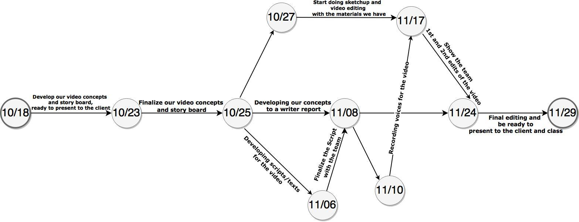

Project Management Roles

We are working as a team to complete this product, so every step will be run past the group and we plan to be intentional about group feedback and support. But we also recognize that every team member has strengths so we have broken up responsibilities that play at everyone’s strengths while setting aside time for feedback and collaboration in our project’s timeline.

The biggest barrier to our project is the responsibility breakdown. The different aspects of the video are specialized, and we have to be diligent about working together to create a cohesive product that each team member holds an equal stake in. Different members will be working on various aspects of the video at different points in the quarter, we plan to have regular check-ins to make sure the workload is equally spread across team members, and that everyone is informed on the state of the video and the tasks that need to be done. Because of the nature of the product and responsibility breakdown, different group members will do the bulk of their portion of the work during different parts of the quarter. But everyone will put in about 10 hours a week on average to put forward an informative video.

Digital Design Team: Jessica and Ben make up the digital design team and will create all the graphics for our video. They will use construction and rendering software to make a 3D design that clearly reflects the mixed use guidelines we choose to highlight in our video, and how they relate to the Upper Pacific site.

Video Editor: Tony
Tony will compile the video and help to ensure that it presents a clear narrative that is both engaging and informative.

Script Writers and Researchers: Zoe and Conor
Zoe and Conor will do the bulk of the research and work as a team to write and record a quality script that fully conveys the message we are trying to share.

Zoe Frumin
Zoe Frumin is a Washington, D.C. native who lives in Seattle Washington and studies Community, Environment, and Planning at the University of Washington. She has a focus in promoting green spaces in urban landscapes because deep down she just really loves city parks. Currently she is working part time with Friends of Waterfront Seattle as a public space activation assistant helping with outreach for the Waterfront Park being built in downtown Seattle.

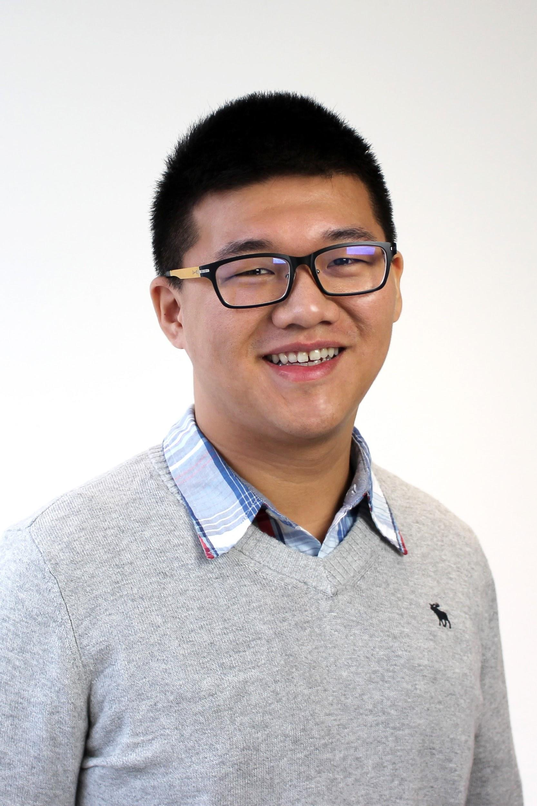
Tony Pai
Tony is an international student from Taiwan. He received his AA at Highline College and transferred to UW’s CEP program to pursue his interests in community development and tourism. He’s passionate about sharing Taiwanese culture with people through videos and in person. He wants to help communities identify, preserve, and share their unique cultural treasures with the world. He aspires to design a new concept of tourism that will contribute to global connectedness and understanding. Currently, he’s interning in Crooked Trails, a non-profit travel company that promotes sustainable and cultural tourism.

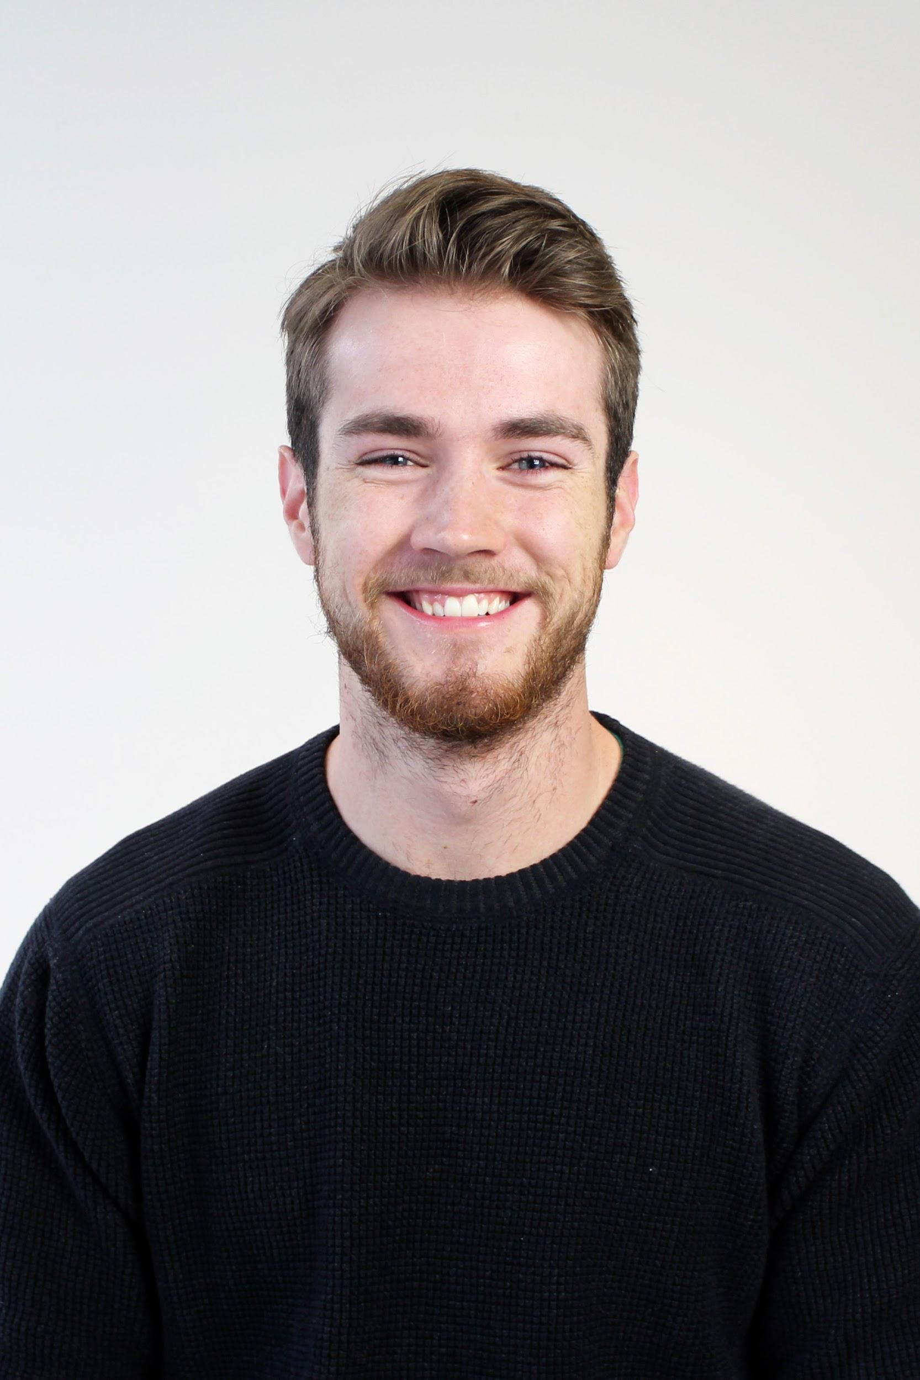
Conor Curran
Conor Curran is a senior in the Community, Environment, and Planning program at the UW. He is also pursuing a minor in the School of Aquatic and Fisheries Science. Conor focuses on finding ways to develop urban environments while minimizing the human impact on surrounding natural environments, particularly natural resource systems such as state fisheries. Conor has always had a passion for fish, and boasts of his pet goldfish, Spud, which he has had since he was 11.

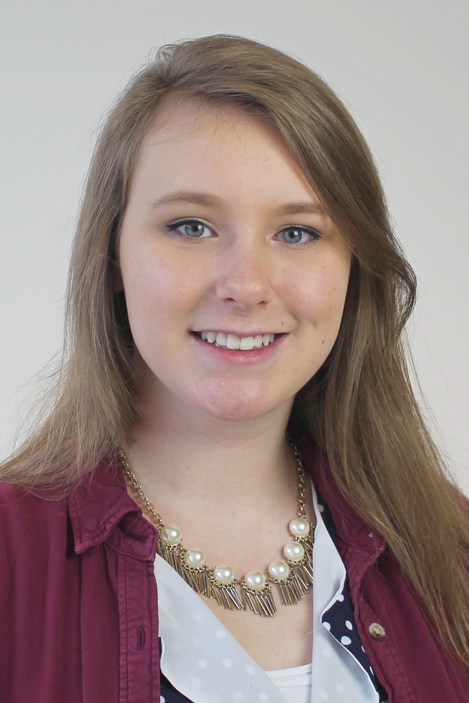
Jessica Jarvi
​Jessica​ ​Jarvi grew up in Lake Stevens, Washington.​ ​She's in her​ ​final​ ​year​ ​of​ ​the Community,​ ​Environment,​ ​and Planning​ ​program​ ​and​ ​has​ ​a​ ​minor​ ​in Urban​ ​Ecological​ ​Design​ ​through​ ​the​ ​Department​ ​of​ ​Landscape​ ​Architecture.​ Her focus subject within​ ​the​ ​major​ is​ ​architecture​ ​and​ ​urban​ ​design.​ Her voyages to​ ​Europe and academic studies​ have inspired her to center her professional work around sustainability and mixed-use development. Over the past 4 years, she's held leadership positions related to community engagement and service, as well as advertising and outreach.

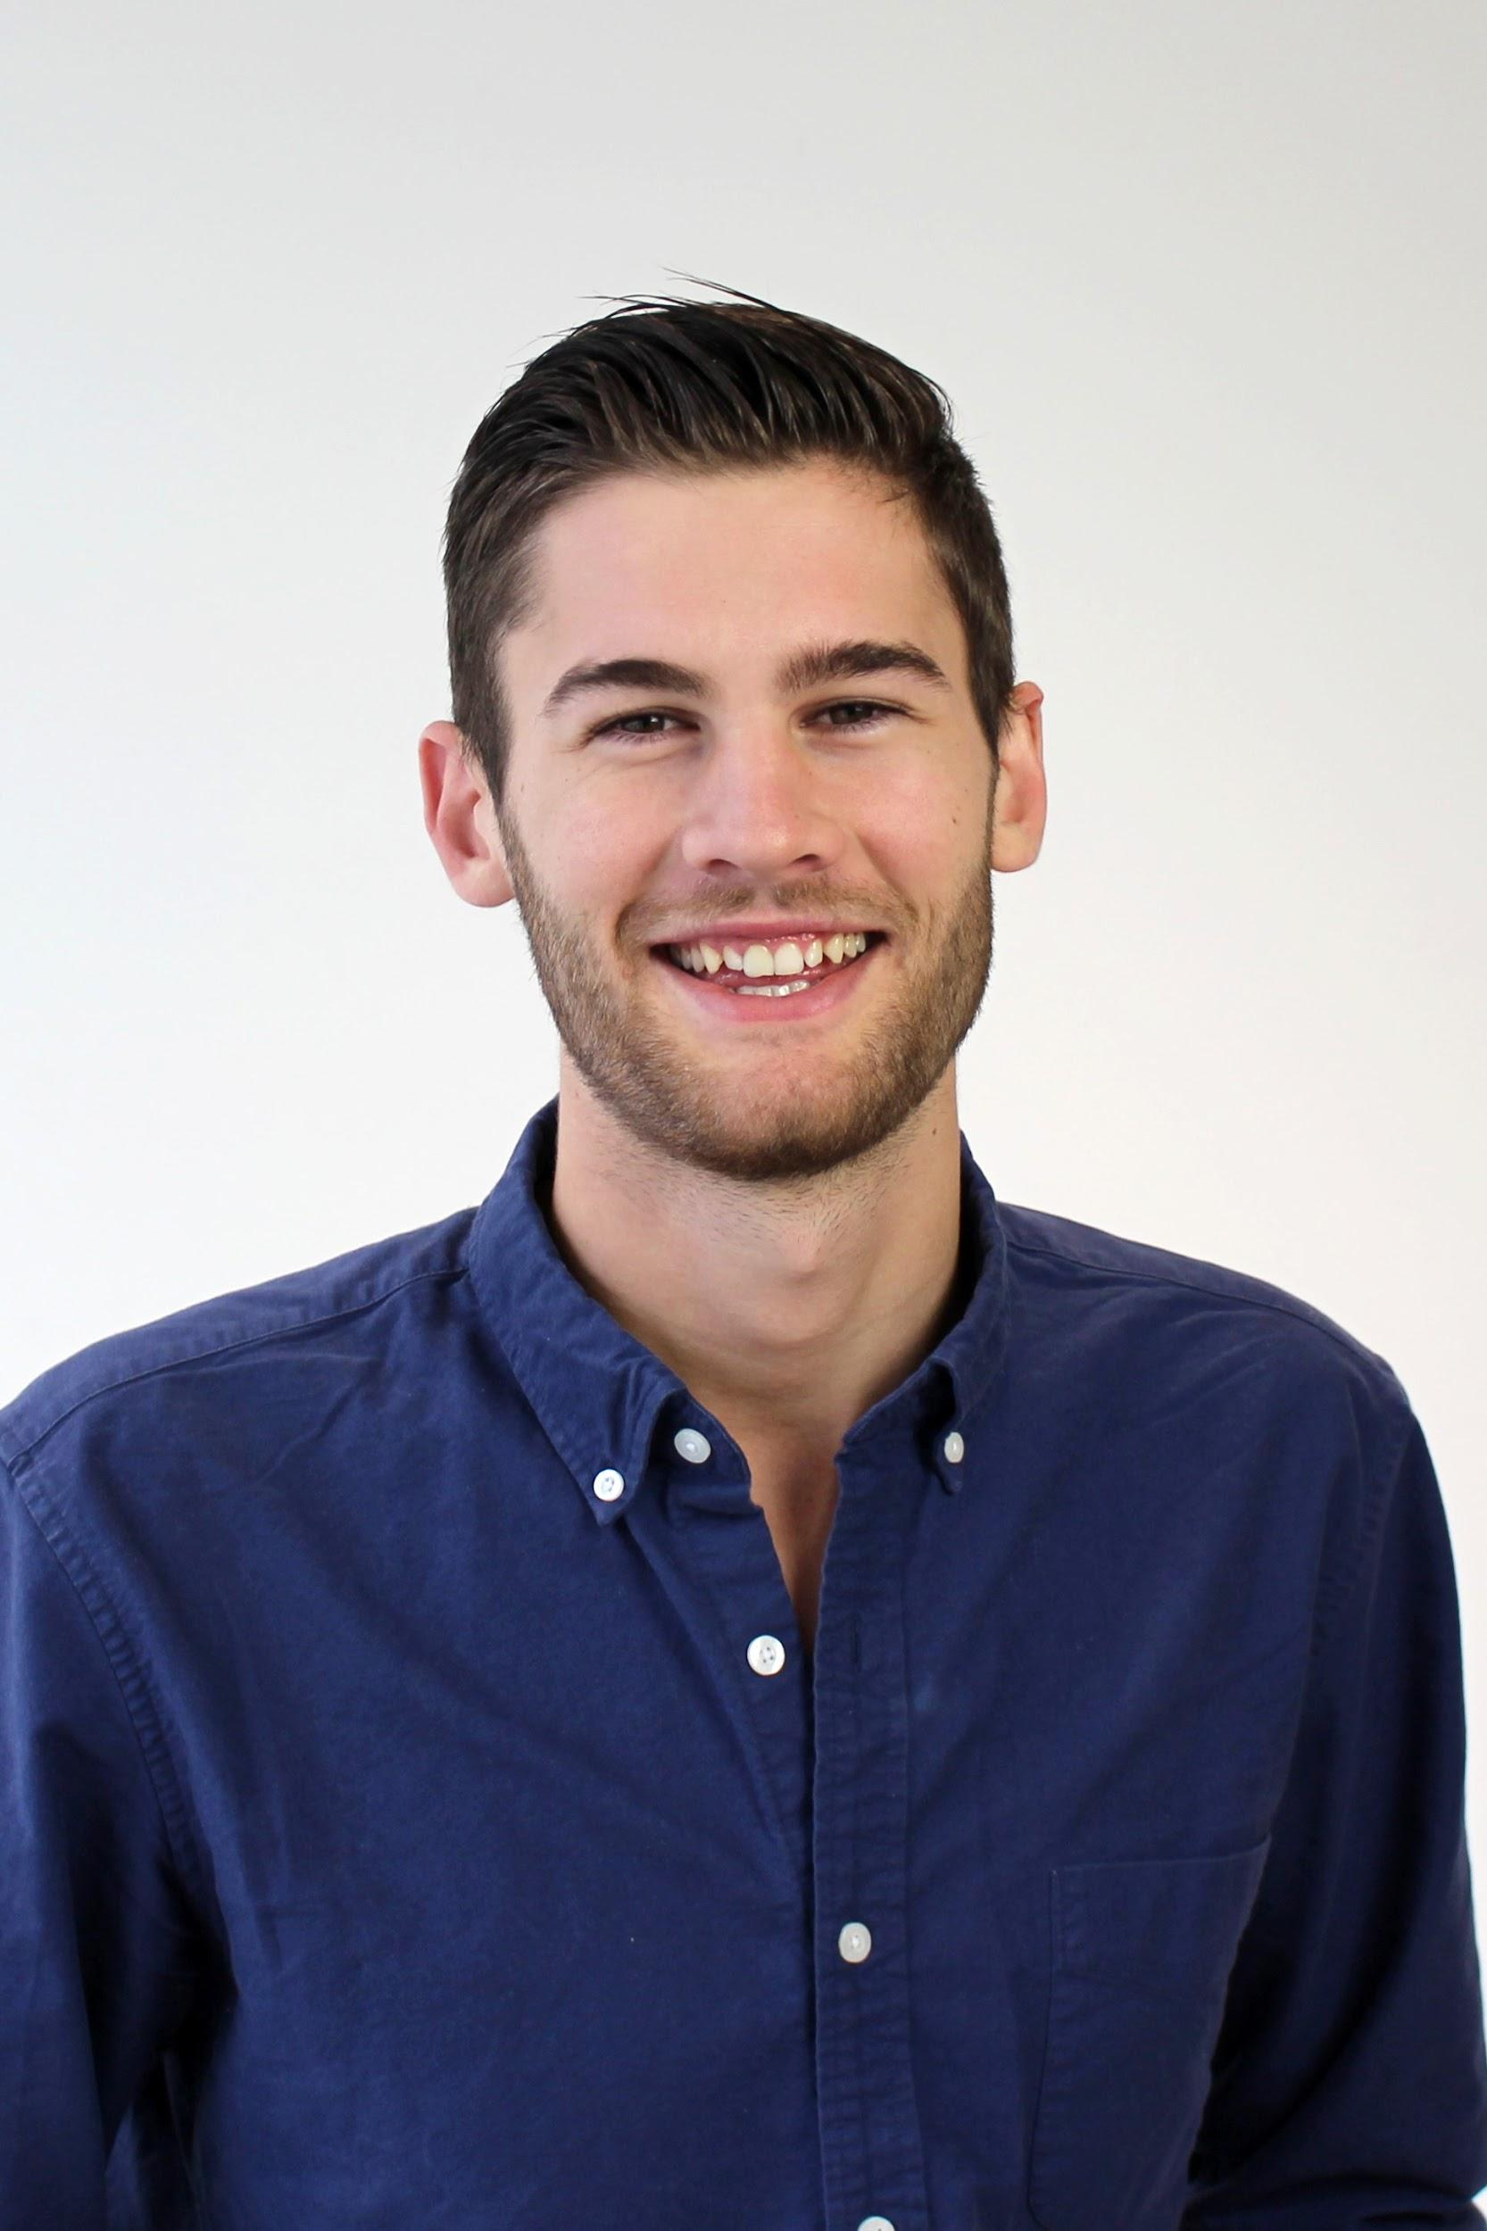
Ben Peabody
Ben Peabody was born in Northern New Jersey. He began his first two years of undergraduate education at The George Washington University in Washington, D.C. where he studied Comparative Politics. After his sophomore year, Ben left school and took a year to study the built environment in a variety of studios and classrooms. He studied and worked in Wisconsin, New York, Paris, Washington, D.C., and Los Angeles. Now, Ben resides in Seattle where he studies urban design and planning with a minor in architecture.

Tacoma Mixed Use Envisioning
Upper Pacific Redevelopment, Fred Meyer
https://www.psrc.org/sites/default/files/trend-population-201707.pdf

Video Abstract:

In the past few years Tacoma has attracted the most residents of any city in Pierce County, and the population is projected to grow more and more in the coming years. One of the strategies the city is using to accommodate this growth while maintaining the character of Tacoma that we know and love is the implementation of Mixed-use Centers.

Title page with pretty scenes of Tacoma and the text “Mixed Use Centers” moving across the screen

These centers will help steer new developments to achieve the City’s long term goals and visions for the future that highlight opportunity, equity, partnerships, and accountability as core values.

Bullet points of opportunity, partnership, equity, and accountability

Mixed Use Centers help Tacoma reach these goals by building sites that
- support a diverse mix of uses
- create housing opportunities that are safe, convenient, and range in price and form,
- Enhance the character and identity of the area while reducing dependence on cars,
- foster efficient provisions of services and utility,
- And support neighborhood business development.

Let’s take a look at the Fred Meyer on Pacific Avenue and 72nd street, as a model for what these Mixed Use Guidelines might indicate for future developments in Tacoma.

Keep in mind this is an example meant to inspire positive routes to growth and is not a part of Tacoma’s current plans for development:

MUC’s provide a hub of commerce and resources to support the diverse communities and neighborhoods which they serve in the greater Tacoma area.

A fundamental quality of Mixed use centers is that they support a variety of resources that help Tacoma’s diverse community thrive. they create community hubs with shopping, recreation, and services near the home and work.
- Visual: opportunities for employment, many services :p

A key aspect of making these centers accessible is a focus on increased Transit Choices. This would entail:
  - Pedestrian oriented walking paths that are safe and comfortable.
    - animate: Lighting, vegetation, and scale
  - Easy transit access that will increase ridership.
    - Animate: transit stations that are accessible and dependable: covered easy to access, and a sign that shows when the next buses are coming?
  - Reduced dependence on cars through access to bikes and transit
    - Animate: increased transit opportunity as well as bike lanes and facilities

Housing Choices in and around mixed use centers are vital for the community,

the mixed use guidelines encourage:
- A Variety of housing available to all, accommodating a mix of incomes, and support of home owners.
  - Visual: Spectrum of housing types, housing that is near to center (within a 5 min drive/ ½ a mile)

6- Livability will be supported in these centers by;
- providing usable public spaces
- Fostering a sense of community
- and pedestrian accessibility
- Visual: green space with people having fun, pathways, and neighborhood identity// architecture

7- The locations contribute to local economy by;
- Creating new and varied employment opportunities
- Attracting patrons from throughout Tacoma
- And Revitalizing current businesses.
- Visual: Retain major employers, close and nice stores, different services next to each other, live near work :)

8 - These projects are products of a great deal of collaboration and will necessarily progress in phases to seamlessly integrate into the existing neighborhoods

- Show a map that highlights potential phases

9- We understand that development often raises concerns among residents. The intent of this video is to demonstrate that Mixed Use Centers are designed with the community in mind.
We hope to inspire among its citizens, a vision for the future of Tacoma.

